Angie Chen

GE1501 18472 SEC 10

Professor Hertz

25 September 2016

Assignment 3 Report: All this Machinery Making Modern Music

As the creation of music evolves into the 21st century, artists started to experiment with less conventional methods of inspiration. One of which included using technology, programming and random numbers. Given a set of parameters and an initial random number, a coded project must output 6 notes.

Meticulous planning of the project first took place. I wrote the logical process of the project in pseudocode to understand and plan the operation of commands. The pseudocode outline is displayed below.

1-3 Include iostream, random integer library, time library

5 Maintain standard versions of functions/variables

7 Function automatically applied to every line of code below

11-4 Ask and store a positive integer other than zero as a seed number from the user

17 Define and declare 6 random integers from 1 to 200.

20-3 Test if the first random number is odd or even for the first note.

26-32 Compare whichever is greater: the 2nd or third number and test if the 2nd number is divisible by 5 or not for the second note.

35-40 Test if the 3rd random number is less than 34, greater than 66, or within the inclusive range of the two numbers for the 3rd note.

43-46 Test if the 6th random number is greater than both the 1st and 2nd random number for the 4th note.

49-52 Compare the sums of the 5th and 6th random number, and the 2nd and 4th random number, or the relation of the 4th random number to 100 for the 5th note.

55-63 Test if the 6th random number is less than 100, greater than 150, or within the inclusive range of the 2 numbers for the 6th note.

In order to ensure that each section of code following a certain logic and rule was effective, I created additional cpp projects to test the program before inserting it into the main project. Below are screenshots of example cpp prototyping to test my understanding of cpp logic.

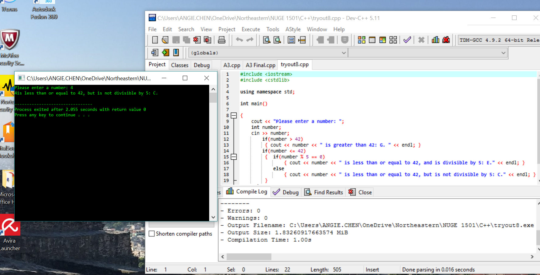

Additionally, I displayed the output of all of the random numbers generated along with the outputted notes to check the effectiveness of my program, as shown below. The final code script is available in the following Appendix.

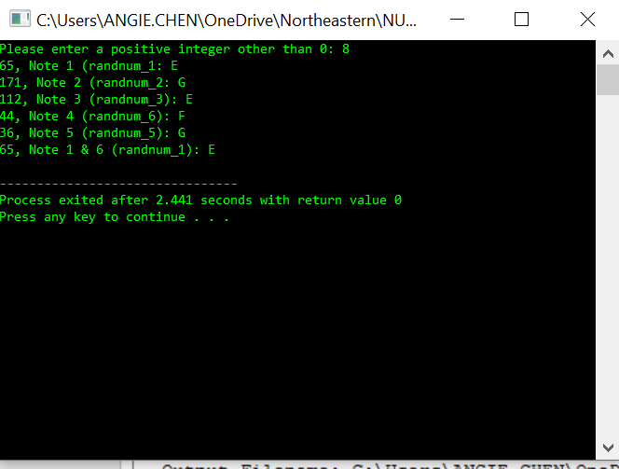

**Appendix**

#include <iostream>

#include <cstdlib>

#include <ctime>

using namespace std;

int main ()

{

cout << "Please enter a positive integer other than 0: ";

int number;

cin >> number;

srand(number);

int randnum_1 = (rand() % 200 + 1), randnum_2 = (rand() % 200 + 1), randnum_3 = (rand() % 200 + 1), randnum_4 = (rand() % 200 + 1), randnum_5 = (rand() % 200 + 1), randnum_6 = (rand() % 200 + 1);

if(randnum_1 % 2 == 0)

{ cout << "C" << endl; }

else

{ cout << "E" << endl; }

if(randnum_2 > randnum_3)

{ cout << "G" << endl; }

if(randnum_2 <= randnum_3)

{ if(randnum_2 % 5 == 0)

{ cout << "E" << endl; }

else

{ cout << "C" << endl; } }

if(randnum_3 < 34)

{ cout << "C" << endl; }

if(randnum_3 > 66)

{ cout << "E" << endl; }

else

{ cout << "B" << endl; }

if(randnum_6 > randnum_1 && randnum_6 > randnum_2)

{ cout << "A" << endl; }

else

{ cout << "F" << endl; }

if( (randnum_5 + randnum_6) >= (randnum_2 + randnum_4) || randnum_4 >= 100) { cout << "G" << endl; }

else

{ cout << "B" << endl; }

if(randnum_6 < 100)

{ if(randnum_1 % 2 == 0)

{ cout << "C" << endl; }

else

{ cout << "E" << endl; } }

if(randnum_6 > 150)

{ cout << "G" << endl; }

if(100 <= randnum_6 && randnum_6 <= 150)

{ cout << "D" << endl; }

return 0;

}

//endprogram